**Soil NPK Sensor**

The soil NPK sensor is suitable for detecting the content of nitrogen, phosphorus, and potassium in the soil, and judging the fertility of the soil by detecting the content of N, P, and K in the soil. The stainless steel probe of the soil npk sensor can be buried in the soil for a long time and is resistant to long-term electrolysis, salt, and alkali corrosion. The shell is vacuum potted and completely waterproof.

* Model: RS-NPK-*-TR
* MOQ: 1 PCS
* Delivery date: within 24 hours
* **Price: Suspend sales**

**About soil npk sensor**

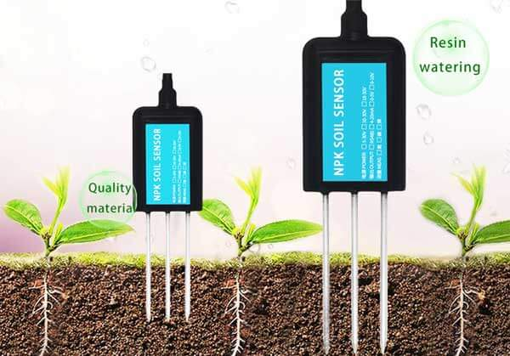

**Soil npk sensor description**

The soil npk sensor is suitable for detecting the content of nitrogen, phosphorus, and potassium in the soil, and judging the fertility of the soil. thereby facilitating the systematic evaluation of the soil condition. Can be buried in the soil for a long time, resistant to long-term electrolysis, corrosion resistance, vacuum potting, and completely waterproof. Soil npk sensors are widely used in soil nitrogen, phosphorus and potassium detection, precision agriculture, forestry, soil research, geological prospecting, plant cultivation and other fields.

**Soil npk sensor features**

1. Simple to use, few operation steps, fast measurement, no reagents, unlimited detection times.  
2. High measurement accuracy, fast response speed, and good interchangeability.  
3. The electrode is made of specially treated alloy material, which can withstand strong external impact and is not easy to damage.  
4. Completely sealed, resistant to acid and alkali corrosion, and can be buried in soil for long-term dynamic testing.  
5. The probe plug-in design ensures accurate measurement and reliable performance.

**Soil npk sensor parameters**

**Power supply**: 5-30VDC  
**Maximum power consumption**: ≤0.15W  
**Operating temperature**: -40~80℃  
**NPK parameters**:  
Range: 0-1999 mg/kg(mg/L)  
Resolution: 1 mg/kg(mg/L)  
Precision: ±2%FS  
**Response time**: ≤1S  
**Protection grade**: IP68  
**Probe material**: 316 stainless steel  
**Sealing material**: Black flame-retardant epoxy resin  
**Default cable length**: 2 meters, cable length can be customized  
**Dimensions**: 45*15*123mm  
**Output signal**: RS485/4-20ma/0-5v/0-10v

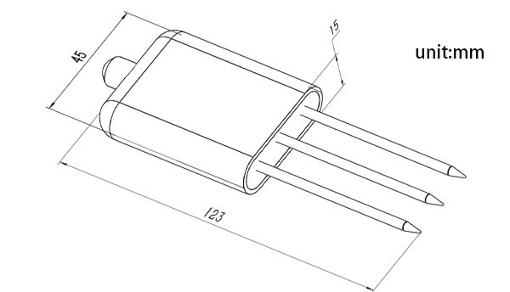

**How do soil NPK sensors work?**  
The soil NPK sensor is suitable for detecting the content of nitrogen, phosphorus and potassium in the soil, and judges the fertility of the soil by detecting the conductivity transformation caused by different nitrogen, phosphorus and potassium concentrations in the soil.

**How to use soil npk sensors**

**1.Quick Test Method**

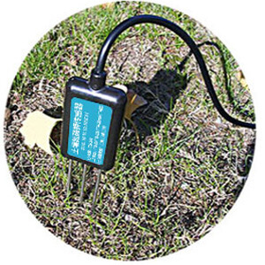

**Select a suitable**

measurement location, avoid rocks, ensure that the steel needle does not touch hard objects, throw away the surface soil according to the required measurement depth, maintain the original tightness of the soil below, hold the sensor vertically and insert it into the soil. Do not shake left and right. It is recommended to measure multiple times for average value within a small range of a measuring point.

**2. Buried measurement method**

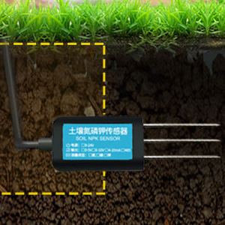

Dig a pit with a diameter> 20cm vertically, insert the sensor needle horizontally into the pit wall at a predetermined depth, and fill the pit tightly. After a period of stability, measurement and recording can be carried out for several days, months, or even longer.

**Precautions**

1. All steel needles must be inserted into the soil during measurement.  
2. Avoid strong sunlight directly shining on the sensor to cause excessive temperature. Pay attention to lightning protection in the field.  
3. Do not bend the steel needle violently, pull the lead wire of the sensor forcefully, and do not hit or hit the sensor violently.  
4. The sensor’s protection grade is IP68, so the whole sensor can be soaked in water.  
5. Due to the presence of radiofrequency electromagnetic radiation in the air, it is not suitable to stay in the air for a long time with electricity.